Analysis of
Lakeman Global Online Retail

By

Olayemi Tega O.

Prepared for the Company Stakeholders

Date: 10 November 2025

Outline:
- Project Summary
- Project scope
- Problem statement
- Problem Definition: Key Challenges
- Global Performance & Operations Dashboard
- Research Questions
- Data cleaning steps
- Insights
- Dashboard features
- Conclusion

Project Summary
Lakeman Global Online Retail operates a complex, global retail business across multiple regions, markets, and product categories. While we possess vast amounts of sales and operational data, our current reporting mechanisms are fragmented, slow, and inconsistent. This lack of a single source of truth hinders our ability to make timely, data-driven decisions, ultimately impacting sales performance, operational efficiency, and profitability.
This document outlines the critical business challenges we face and formally proposes the development of a centralized Global Retail Performance and Operations Dashboard. This dashboard is intended to provide a unified, real-time view of our key performance indicators (KPIs), empowering stakeholders at all levels to identify issues, capitalize on opportunities, and align strategic objectives across the entire organization.

Project Scope
Purpose: build an interactive Excel dashboard that tracks sales, profit, customer behaviour, product performance, and shipping efficiency across all regions that helps the company make smarter decisions on inventory, marketing, shipping, and growth.
Scope: Analysis of sales data from January 2021 to January 2024 with focus being on retail sales performance and operational efficiency.

Problem statement
Carry out prescriptive analysis on the sales data given. The analysis aims to help the company make better decisions on inventory, marketing, shipping and growth moving forward.

Project Objectives
- Analyse the sales data received from Lakeman Global Online retail.
- Uncover the insights that matter most: where the money is made, where it’s lost, who the best customers are, what’s selling, what’s not, and why.
- Build an interactive dashboard for the company to understand sales performance and operational efficiency.
Problem Definition: Key Challenges
I have identified three primary areas of challenge that this analysis aims to address:
- Fragmented and Delayed Performance Visibility:
Currently, decision-makers lack a holistic, up-to-date view of global performance. Data is siloed within regional teams, separate systems, and static reports (e.g., weekly PDFs, Excel files).
Business Impact: Missed revenue opportunities, inability to respond quickly to market shifts, and strategic decisions based on outdated or incomplete information.
- Inefficient Operational Execution
A lack of integrated data leads to suboptimal performance in core retail operations, specifically in inventory management, product shipping and workforce productivity.
Business Impact: Increased shipping costs, lost sales, lower customer satisfaction, and higher operational expenses.
- Lack of Actionable Customer and Channel Insights
We struggle to understand the unified customer journey and the relative performance of our different regions.
Business Impact: Ineffective marketing campaigns, poor customer experience and missed opportunities for personalization and growth.

Global Performance & Operations Dashboard
To address these challenges, the development of a centralized, interactive, and real-time dashboard has been proposed. This dashboard is meant to address the problems by:
Providing a Single Source of Truth: Consolidate data from all relevant sources (fact_sales data, customer data, location data, product data) into one unified platform with standardized metric definitions.
Enabling Real-Time Monitoring: Offer stakeholders at the global, regional, and store levels immediate visibility into KPIs, allowing for rapid response to emerging issues and opportunities.
Driving Data-Driven Decisions: Replace gut-feel decisions with empirical evidence by providing clear, visual, and actionable insights into sales trends, inventory health, and operational efficiency.
Improving Operational Alignment: Foster alignment between global strategy and local execution by ensuring all teams are working from the same set of data and goals.
Research Questions
- What are our total sales across all regions (top 10)?
- Which product categories are driving the majority of our sales growth, and which are stagnating or in decline?
- What is the total sale in each region?
- What is the total sale in each department?
- Which customer segments are underperforming, and what strategies can we implement to boost their sales?
- What are the key drivers behind our best-selling products, and how can we leverage them for future launches?
- What is the monthly total sales trend like?
- What is total Sale by Country?
- How many customers for we have?
- What are the primary characteristics (e.g., transaction type, order status, customer segment and Purchase Level) of our most loyal customers versus those who churn after one purchase?
- How does the performance of our different shipping carriers (e.g., on-time delivery rate, shipping mode) vary by region?

Data cleaning steps
Shipping Data:
- Created the main sales dataset by arranging the sales data columns properly, starting with the shipping data from the Facts_Sales worksheet side by side to reflect all shipping data first.
Customer Data:
- Inserted a new column to merge the customer first and last name.
- Inserted two new columns to ensure that all names are in proper case using the proper function and used the trim function to remove excess spaces from the column.
- Created a new worksheet named Sales Pretable Lookups to merge all necessary columns to form my table.
- Used XLOOKUP function to lookup the customer’s full name using the customer_id from the fact_sales and Sales Pretable Lookups Worksheets.
- Used XLOOUP function again to lookup the customer segment using the Customer_id the fact_sales and Sales Pretable Lookups Worksheets.
- Inserted the transaction_type column into the Sales Pretable Lookups worksheet via XLOOKUP function.

Location Data:
- Copied the location_id into the Sales Pretable Lookups worksheet.
- Used XLOOUP function to lookup and generate the Order region, market, latitude and longitude and Order_Country columns from the dim_Location worksheet.
Order and Product Data:
- Copied the order_id, order_quantity and order_status columns into the Sales Pretable Lookups worksheet.
- Copied the product_id column into the Sales Pretable Lookups worksheet.
- Used XLOOUP function to lookup and generate the product_price, department and product_category columns from the dim_Product worksheet using the product_id as lookup value.
- Calculated Product_sales column by multiplying the product_price and the Order_quantity together.
- Created a column named Sales Category using the IFS function to show customer purchase power.
Sales Dataset:
- Created a new worksheet and named it Sales Dataset.
- Copied and pasted each column (especially the lookedup columns) as a value to avoid the #SPILL error from occurring.
- Formatted the computed columns as a table.
- Before removing duplicates, 103,633 rows were generated column headers inclusive. Then, 6089 duplicates were removed, leaving 97,543 (aside from the header row) unique values void of blanks as well.

Pivot Tables:
I inserted all necessary pivot tables, properly named each table and I used the INDEX, MATCH, MAX and TEXT functions to write a formula to generate the highest sales, orders for each pivot table and named each cell they were located.
Charts:
I created all necessary charts using the pivot tables, charts such as line chart, bar and column charts, maps, doughnut charts etc and appropriately adjusted their designs to suit my dashboard design.

Insights
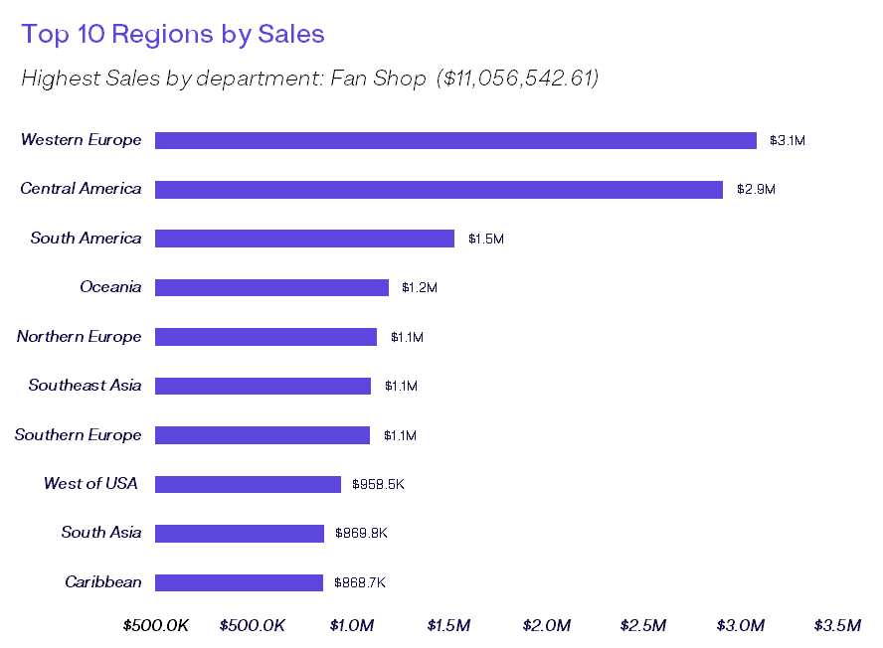
Insight I:
Top Regions by Sales: Based on this analysis, the region with the highest sales is Western Europe with a total of $3.1 Million with the least being Central Asia with a total of $60.1 thousand.

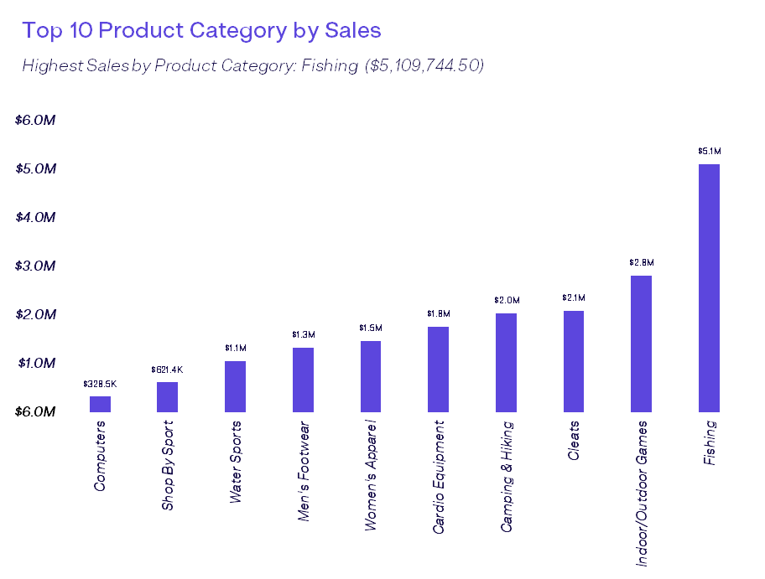
Insight II:
Top Product Category by Sales: The product category with the highest sales is Fishing with a total of $5.1 Million with the least being CDs with a total of $1.8 thousand. This is due to customers preferring fishing products the most.

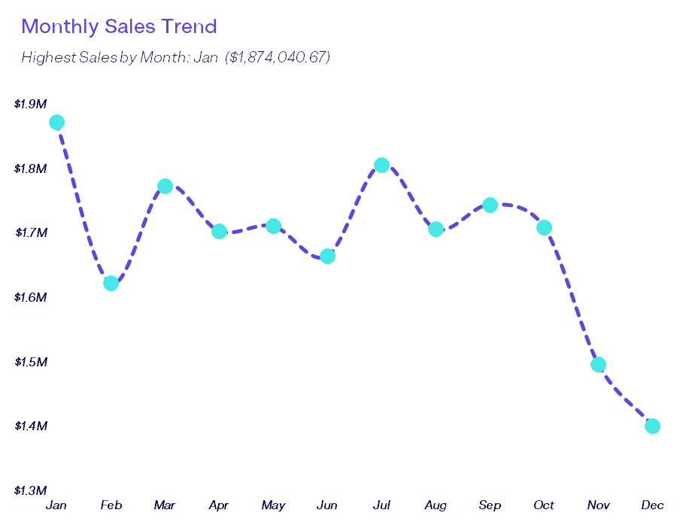
Insight III:
Monthly Sales Trend: January shows the most sales with a value of $1.9 million showing that the start of the year brings about the most sales with December being the least with a value of $1.4 million.

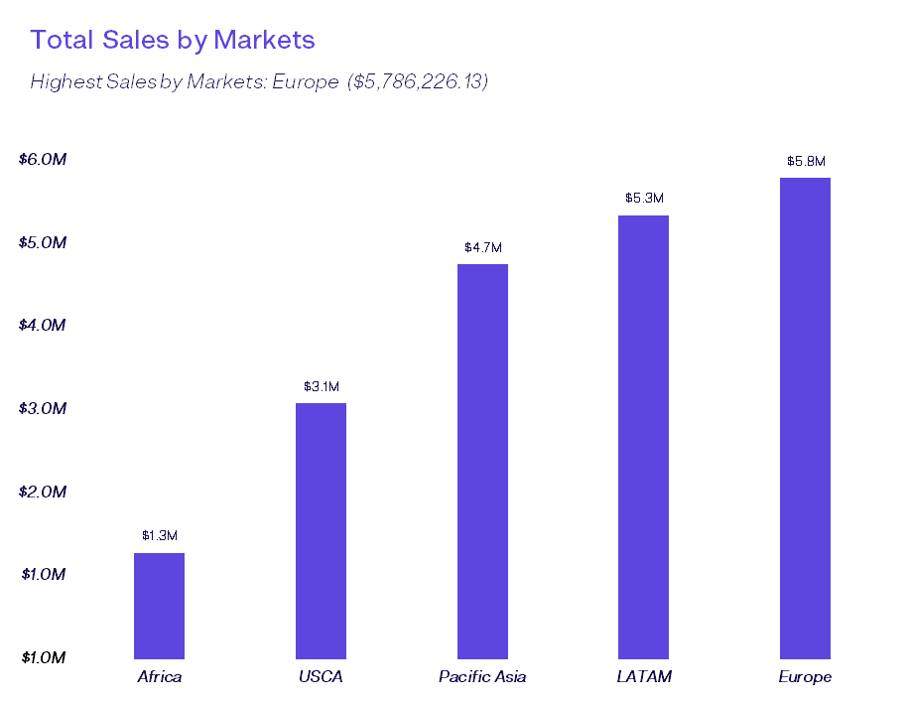
Insight IV:
Market Sales Trend: The analysis shows that Europe is the market with the largest sales valued at $5.8 million and Africa being the smallest valued at $1.3 million.

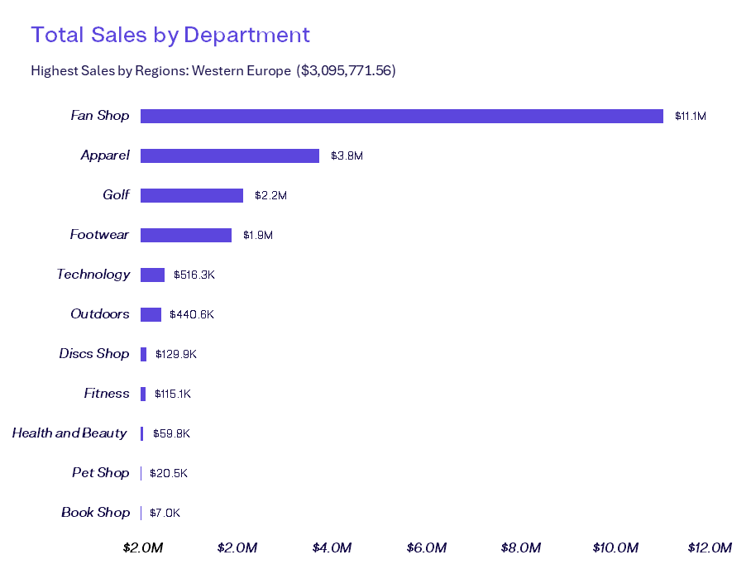
Insight V:
Departmental Sales: The analysis shows that Fan Shop is the department with the largest sales valued at $11.1 million and Book Shop being the smallest valued at $7.0 thousand.

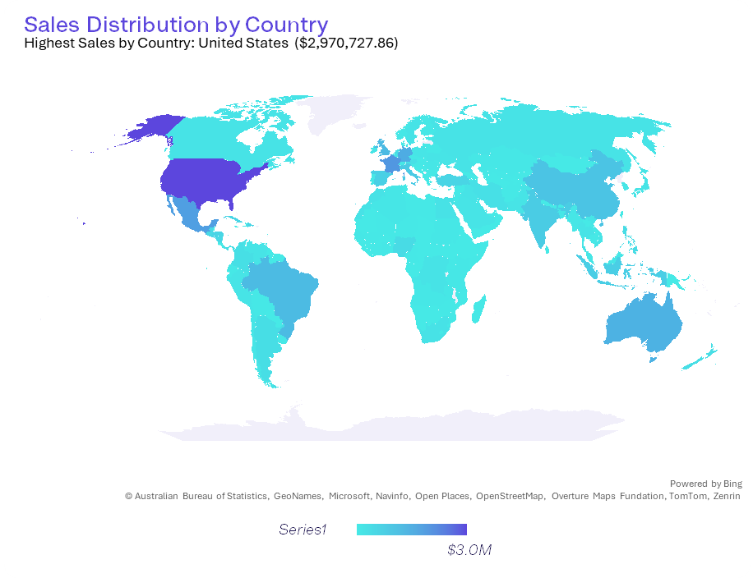
Insight VI:
Sales by Country: The analysis shows that the United States of America (USA) is the country with the largest sales valued at $2.97 million and South Sudan in Africa being the smallest valued at $49.98.

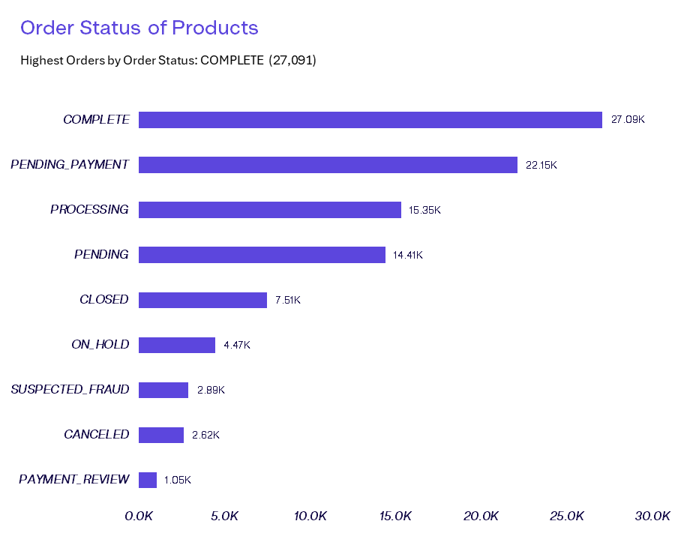
Insight VII:
Product Order Status: The COMPLETED orders are the most valued at 27.09 thousand orders and the least being PAYMENT_REVIEW with 1.05 thousand still having pending payments.

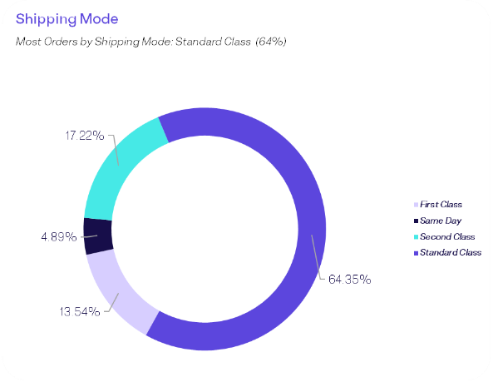

Insight VIII:
Shipping Modes: The shipping mode most used is the standard class with 64.35% of the total shipping modes used by Lakeman Global Online Retail.

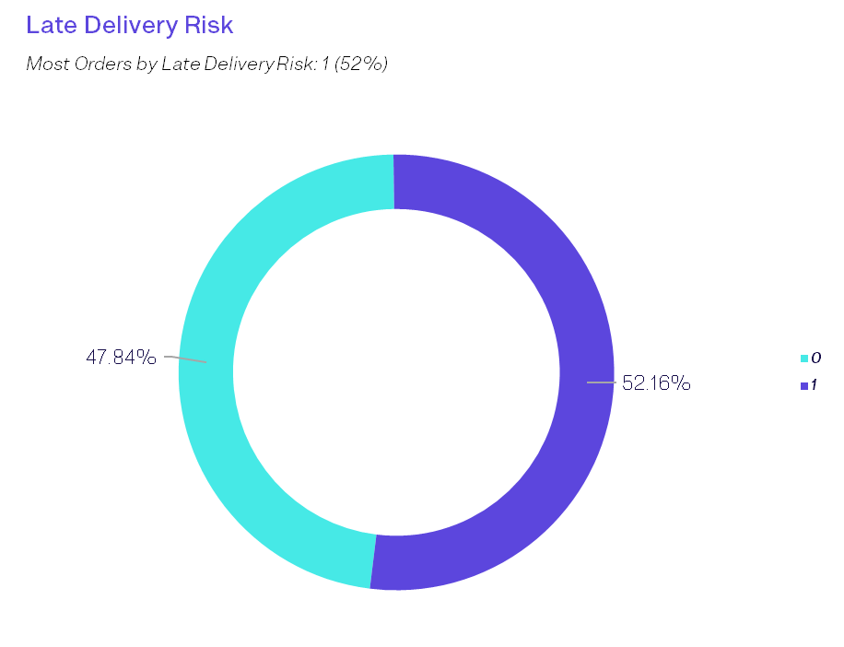
Insight IX:
Late Delivery Risk: The orders with the least delivery risk ranks slightly higher than orders with more late delivery risk being valued at 52.16% of the total.

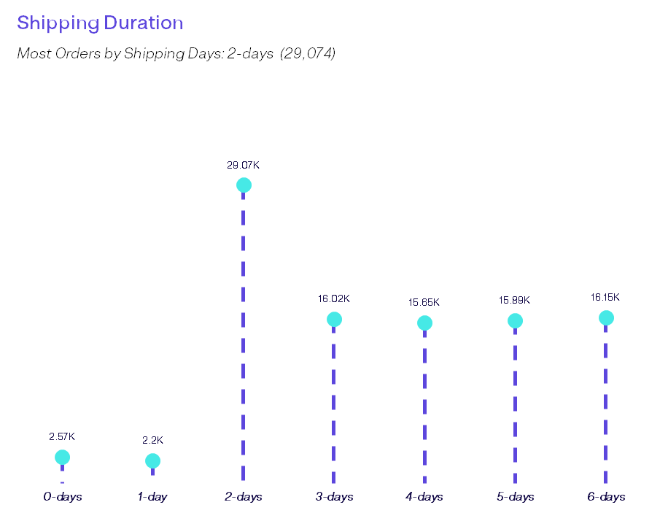
Insight X:
Shipping Duration: Based on the analysis done, the 2-day shipping duration ranks highest at 29.07 thousand orders and the least as the 1-day duration with its value as 2.2 thousand orders.

Dashboard Features
Dashboard Overview: The attached MS Excel dashboard provides an at-a-glance view of Sales Performance, Shipping Trends, Customer Behaviour and Operational Efficiency of Lakeman Global from January 2021 to January 2024.
Key Features:
- Slicers: Users can slicers by Customer Segment, Financial Years, Transaction Type, Delivery Status, Sales Category and Order Status to drill down into specific segments and show chart interactivity.
- Key Performance Indicators (KPIs): The top of the dashboard shows live KPIs: Sales, Product Quantity and Number of Orders.
- Buttons: The left side of the dashboard has buttons with hyperlinks that when clicked will lead to the pivot tables, the sales dataset and the dashboard itself.
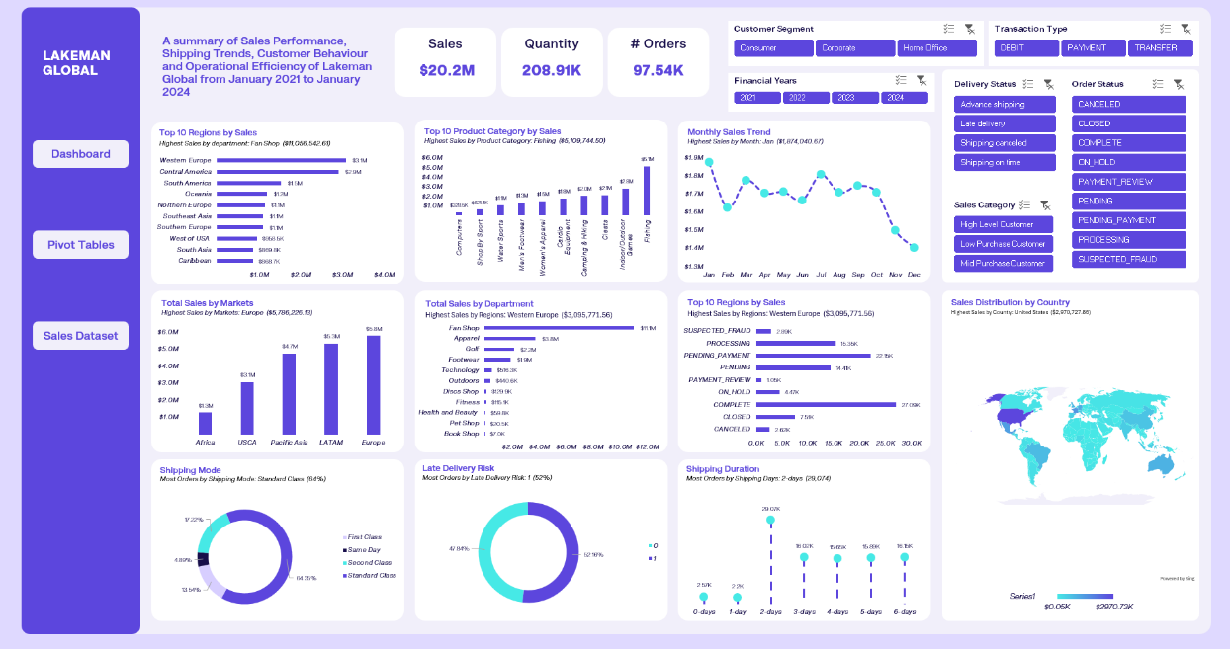
- Charts: Different charts gotten from the pivot tables that show at a glance what they mean with titles and subtitles that show the highest within the table.

Conclusion
The Lakeman Global Retail Sales performance and operational efficiency analysis reveals significant insights into sales performance, shipping trends, customer behaviour and operational efficiency. By increasing sales of different product categories, reducing late delivery risk by at least 50%, Improving lower reached markets such as Africa, improving customer experience by providing discount incentives to their Low Purchase Customers and personalised promotions for all customers to increase their purchase power as well as ensuring that departments that are not functioning well start to function better, the company can improve their sales performance, the behaviour of customers and operational efficiency.

